Project
- Site-21-Api-Ng-Publishing-PostGres-Docker-Fallback
  - Copied from: Site-20-Api-Ng-PhotoManagement
- For the “MySocialConnect-API”
  - dotnet restore
  - dotnet build
  - Go to project : MSC.WebApi
    - dotnet build : to build
    - dotnet run : to run the api

New Resources
MSC.Core | MSC.WebApi
 | Controllers/FallBackController
 | MSC.WebApi/Dockerfile
 | .dockerognore at solution root

Resources updated
MSC.Core | MSC.WebApi
MSC.Core/Extensions/AppServiceExtensions.cs | Programs.cs
Appsettings.Development.json
MSC.Core/DB/Data/SeedData.cs
AppSettings.json

Clear Database
- New migrations created
- Clear the users
- dotnet ef database drop
- dotnet ef database update

Fix NameSpaces For WebApiControllers
Open all controller and change the name space to
namespace MSC.WebApi.Controllers;

Setup Angular App

Angular App Build
Follow “Serve Angular from Api” section in the following doc
020 Project21 -Ng-Publishing-PostGres-Docker-Fallback.docx
Only do below after performing above.

.gitignore
Do not push the wwwroot folder getting generated in MSC.WebApi to git so add it to .gitignore file
########################
# wwwroot #
########################
## production build is getting pushed to MSC.WebApi/wwwroot folder
wwwroot

ServeAngular app from API

Program.cs
After performing above NG app step, provide instructions for the api to server default and static files
app.UseAuthorization();

/***Custom Section Start***/
//Need to serve static content after moving NG SPA deployment to wwwroot folder in the MSC.WebApi
//this will look for index.htm or index.html
app.UseDefaultFiles();
//by default will look for the wwwroot folder and will serve the content from there
app.UseStaticFiles();
/***Custom Section End***/

app.MapControllers();

Run
Issue command
> dotnet run
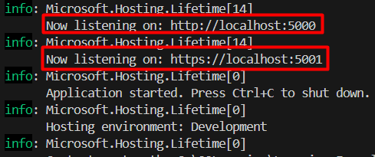

NG App Access
URL https://localhost:5001/ will take to the NG app
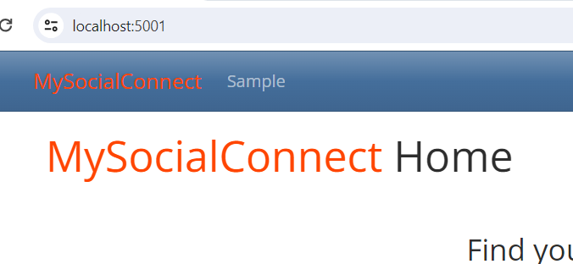
And the NETWORK tab
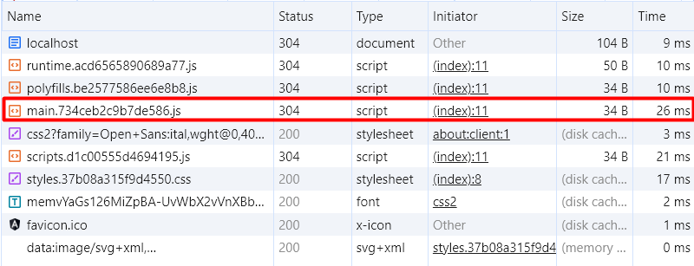

Swagger Access
URL https://localhost:5001/swagger will take to the swagger
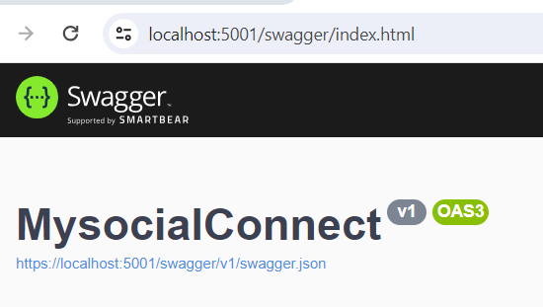

Issue with Run
- Login as one of the users and it will work.
- Refresh the page and it will show following error
- The reason is, api doesn’t have an end point for members
  - To fix this, will need to create a FallBack Controller and pass the responsibility to angular to handle it
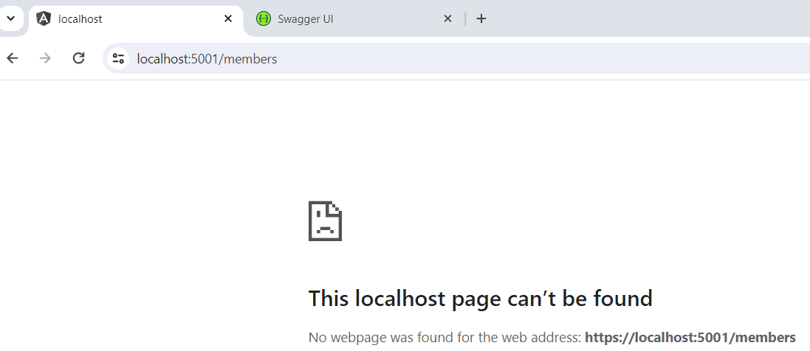

MSC.WebApi/Controllers/FallBackController
- We’ll need to tell api about the routes that it doesn’t know how to handle.
- We will tell the API to pass that responsibility to Angular App
using System.IO;
using Microsoft.AspNetCore.Mvc;

namespace MSC.WebApi.Controllers;

//Inherit from Controller since we wil be using the view - index.html from angular app
public class FallbackController : Controller
{
public ActionResult Index()
{
//get the index.html from wwwroot folder
var currentDirectory = Directory.GetCurrentDirectory();
var indexHtml = Path.Combine(currentDirectory, "wwwroot", "index.html");
return PhysicalFile(indexHtml, "text/HTML");
}
}

Programs.cs
/***Custom SignalR EndPoint End***/

/***Custom Section FallBackController Start***/
app.MapFallbackToController("Index", "Fallback");
/***Custom Section FallBackController End***/

/***Custom Section Seed Data Start***/

Run Again
Run again, login and then refresh members and it should work

Docker Desktop

Turning On windows Features
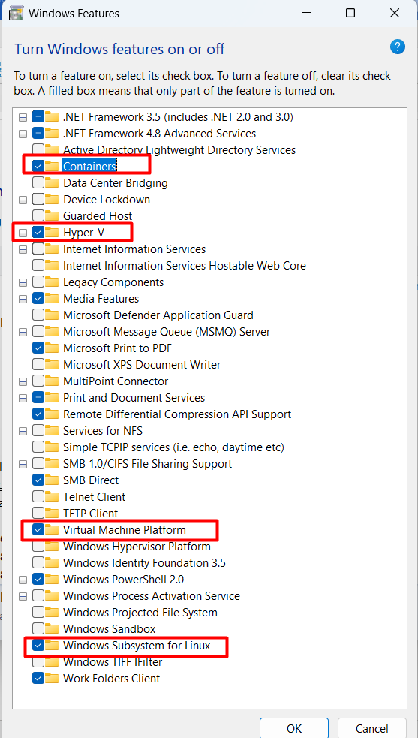

Download Docker Desktop
https://www.docker.com/products/docker-desktop/
https://docs.docker.com/desktop/install/windows-install/ downloaded from here

Install Docker Desktop
Installed with defaults.

Account
If you are not registered with docker then do create a free account. This will be need to post the app image to docker hub.

Setup PostgreSQL Container

Command
- In command prompt go to your root folder for the project (not api) and create a postgres container.
- Keep the password simple since it will be used on the local machine
- Also provide ports as 5432 for both internal and external ports
- Run it in detatched mode
- And provide the latest version for the postgres
Container name | postgres
USEr Id | postgres (DEFAULT)
POSTGRES_PASSWORD | postgrespw
Internal:External ports | 5432:5432
-d | Run in detached mode and not interactive mode
Postgres:version | postgres:latest

>docker run --name postgres -e POSTGRES_PASSWORD=postgrespw -p 5432:5432 -d postgres:latest
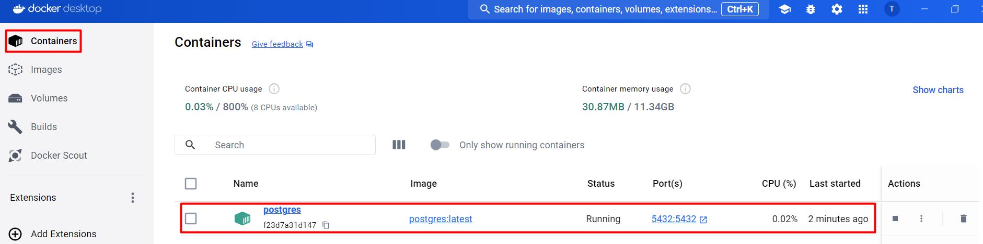

CommandPrompt Log
Unable to find image 'postgres:latest' locally
latest: Pulling from library/postgres
09f376ebb190: Pull complete
119215dfb3e3: Pull complete
e02bbc8c8252: Pull complete
061f31803c55: Pull complete
accd4903f49a: Pull complete
2016ff8e6e3a: Pull complete
088e651df7e9: Pull complete
ed155773e5e0: Pull complete
ffebb35d2904: Pull complete
293f0bec643a: Pull complete
1655a257a5b5: Pull complete
4ddba458499d: Pull complete
90e48ae03559: Pull complete
822c1a513e6a: Pull complete
Digest: sha256:1bf73ccae25238fa555100080042f0b2f9be08eb757e200fe6afc1fc413a1b3c
Status: Downloaded newer image for postgres:latest
f23d7a31d1474ec6d0088b77b3a95d272f33964c155885e798d7c65843c4c830

Look At PostGreSQL Database
Go to extensions and install PostgreSQL to look at the database.

Extension
PostgreSQL by Chris Kolkman v1.4.3
You can also install the Microsoft one as well.
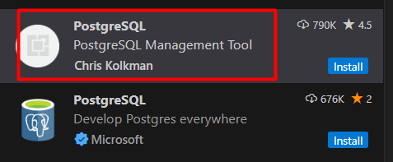 | 

Switching the Database - PostGreSQL

Drop SQLite DB
> dotnet ef database drop
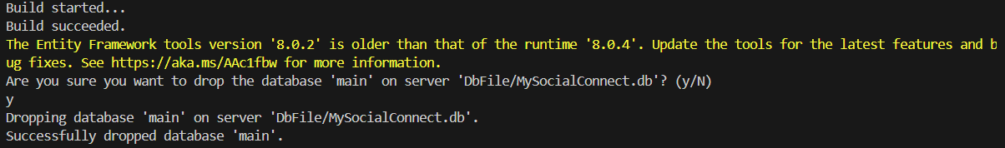

Add PostGreSQL Package
Npgsql.EntityFrameworkCore.PostgreSQL

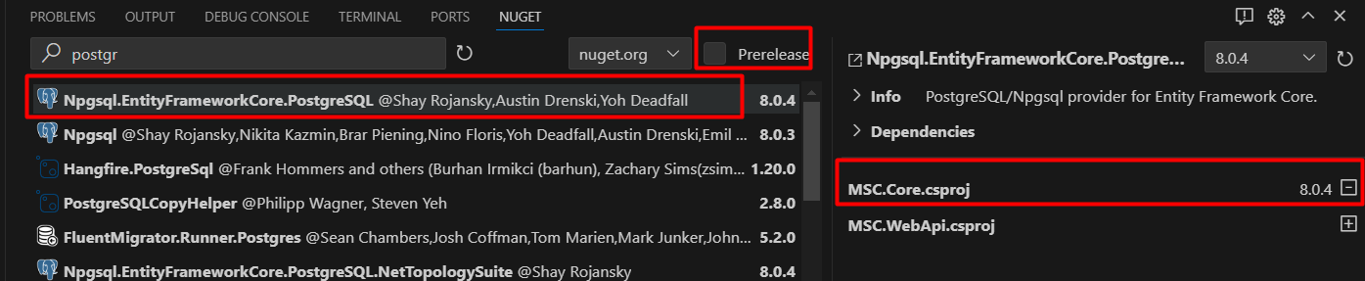
It will get added to the csproj file
<PackageReference Include="Npgsql" Version="8.0.3" />
<PackageReference Include="Npgsql.EntityFrameworkCore.PostgreSQL" Version="8.0.4" />

Update Connection to User PostgreSQL

appsettings.Development.json
Go to appsettings.Development.json
For postgresql the default userid is used so it is postgres
From | To
"ConnectionStrings": {  "DefaultConnection": "Data source=DbFile/MySocialConnect.db"  }, | "ConnectionStrings": {  "DefaultConnection": "Server=localhost; Port=5432; User Id=postgres; Password=postgrespw; Database=MySocialConnect2024"  },

Update AppServiceExtensions to Use PostGreSQL

MSC.Core/Extensions/AppServiceExtensions.cs
public static IServiceCollection AddDbContext(this IServiceCollection services, IConfiguration config)
{
//***** check Program_site03_before_extensions.txt for details - in the root of the project setup*******

//DBContext and connection string
//Migration assembly is needed since DBContext is in MSC.Core where as the Migrations are getting created in MSC.WebApi via
//dotnet ef migrations add InitialCreate -o DbFile/Migrations
//if every thing is in MSC.WebApi then b is not needed.
services.AddDbContext<DataContext>(opt => {
//using postgreSQL
/*
opt.UseSqlite(config.GetDefaultConnectionString(),
b => b.MigrationsAssembly("MSC.WebApi")
);
*/
opt.UseNpgsql(config.GetDefaultConnectionString(),
b => b.MigrationsAssembly("MSC.WebApi")
);

});
return services;
}

Update Migrations

Delete MSC.Webapi/Dbfile/Migrations
Migrations have been created with “Sqlite”. For this delete the full folder manually
- MSC.WebApi/Dbfile/Migrations

Create Migrations for PostGreSQL
>dotnet ef migrations add PostGreSQLInitialCreate -o DbFile/Migrations
Specify the Migrations folder again since it has been deleted
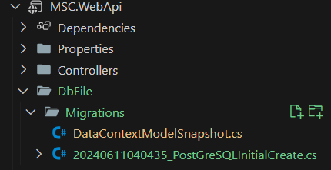

Move Removing the Connections to Seed Data
Currently removing the connections is sitting in programs.cs. Move it to SeedData.

MSC.core/DB/Data/SeedData.cs
Add a new method
/// <summary>
/// clear SignalR connections
/// </summary>
/// <param name="context"></param>
/// <returns></returns>
public static async Task ClearSignalRConnections(DataContext context)
{
//for sqlite check the program.cs

/*
Alternate to this is truncate below
context.SignalRConnections.RemoveRange(context.SignalRConnections);
await context.SaveChangesAsync();
*/

var remove = "TRUNCATE TABLE \"SignalRConnections\"";
//var remove = @"DELETE FROM \"SignalRConnections\"";
await context.Database.ExecuteSqlRawAsync(remove);
}

Programs.cs
Go to programs.cs and comment the current removing the connections code.
/*Moved to SeedData
try{
//Remove old MessageHub Connection app start. TRUNCATE doesn't work with SQLITE
//way #1
//context.SignalRConnections.RemoveRange(context.SignalRConnections);
//way #2
//var remove = @"TRUNCATE TABLE [SignalRConnections]";
var remove = @"DELETE FROM [SignalRConnections]";
await context.Database.ExecuteSqlRawAsync(remove);
}
catch (Exception ex){
logger.LogError(ex, ex.Message);
}
*/
await SeedData.ClearSignalRConnections(context);

Run
Run the app by issuing command
>dotnet run
If any errors show then always drop the database
> dotnet ef database drop

Error: Cannot write DateTime with Kind=Unspecified to PostgreSQL type 'timestamp with time zone', only UTC is supported
Error in SeedData
MSC.Core\DB\Data\SeedData.cs:line 143
Issues is not using UTC dates inside the MSC.Core/DB/Data/UserSeedData.json
"CreatedOn": "2023-02-08",
"LastActive": "2023-05-24",

Option1: Convert to UTC when seeding /Core/DB/Seed.cs
Convert the dates read from the json to utc
Method SeedUsers(UserManager<AppUser> userManager, RoleManager<AppRole> roleManager)
foreach(var user in users){
//with photo managment, make the first photo isApproved
if(user.Photos != null && user.Photos.Any()){
user.Photos.First().IsApproved = true;
}

user.UserName = user.UserName.ToLowerInvariant();
user.CreatedOn = DateTime.SpecifyKind(user.CreatedOn, DateTimeKind.Utc);
user.LastActive = DateTime.SpecifyKind(user.LastActive, DateTimeKind.Utc);

Option2: Convert to UTC
- ensuring all DateTime.Now as well as DateTime.Today were changed to DateTime.UtcNow
- updating the seed data to use UTC/ISO dates. For this, append "T00:00:00Z" to each timestamp in the seed data json file w/ the following find-replace regex in vs code:
find: "(\d{4}-\d{2}-\d{2})"
replace: "$1T00:00:00Z"

Check the Database
Click the PostgreSQL icon  Click + to add the connection  Add localhost  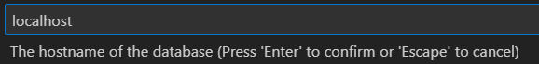  Add user as postgres    Add password as postgrespw    Add port number as 5432  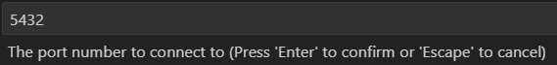  Use standard connection  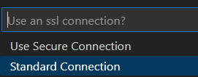  Pick the database to show  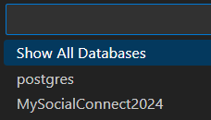  Name the database: Local-MySocialConnect2024   | Full connection we have already placed in the appSetting.Development.json so follow that for the prompts  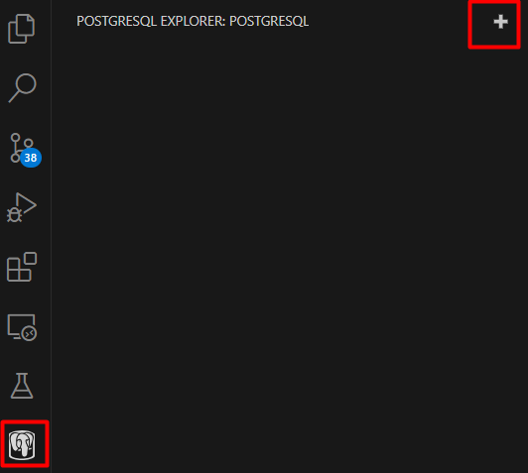

Check section Site 21 - POSTGRESQL in the UserIds And Passwords.txt for details.

Convert App to Docker Image

Install Docker Extension
Docker By Microsoft
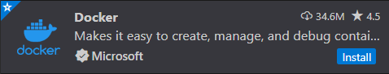
This will give us
 | 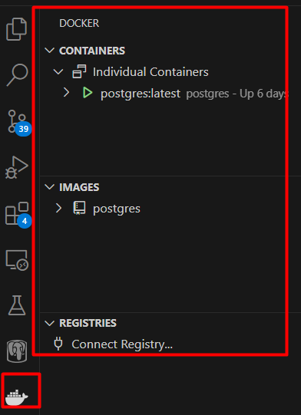

Create Dockerfile

MSC.WebApi/Dockerfile
Create Dockerfile inside the MSC.WebApi project
#Multiproject solution
#All projects are at the same level
#Project1: MSC.Core
#Project2: MSC.WebApi
#Entry project is MSC.WebApi
#Docker file created in MSC.WebApi
#.dockerignore placed at solution level

#image to start from and put a reference as base, sdk is only for the build since it is quite large
FROM mcr.microsoft.com/dotnet/aspnet:8.0 AS base

#add the work dir that the container will start in
#any future commands will happen in this dir
WORKDIR /app

#build
FROM mcr.microsoft.com/dotnet/sdk:8.0 AS build
ARG BUILD_CONFIGURATION=Release
WORKDIR /src

#copy the csproj and restore as distinct layers
COPY ["MSC.WebApi/MSC.WebApi.csproj", "MSC.WebApi/"]
COPY ["MSC.Core/MSC.Core.csproj", "MSC.Core/"]
RUN dotnet restore "./MSC.WebApi/./MSC.WebApi.csproj"
COPY . .
WORKDIR "/src/MSC.WebApi"
RUN dotnet build "./MSC.WebApi.csproj" -c $BUILD_CONFIGURATION -o /app/build

FROM build AS publish
ARG BUILD_CONFIGURATION=Release
RUN dotnet publish "./MSC.WebApi.csproj" -c $BUILD_CONFIGURATION -o /app/publish /p:UseAppHost=false

FROM base AS final
WORKDIR /app
COPY --from=publish /app/out .
ENTRYPOINT ["dotnet", "MSC.WebApi.dll"]

.dockerignore
Create the .dockerognore at the solution level. At the minimum put **/bin and **/obj
**/.classpath
**/.dockerignore
**/.env
**/.git
**/.gitignore
**/.project
**/.settings
**/.toolstarget
**/.vs
**/.vscode
**/*.*proj.user
**/*.dbmdl
**/*.jfm
**/azds.yaml
**/bin
**/charts
**/docker-compose*
**/Dockerfile*
**/node_modules
**/npm-debug.log
**/obj
**/secrets.dev.yaml
**/values.dev.yaml
LICENSE
README.md
!**/.gitignore
!.git/HEAD
!.git/config
!.git/packed-refs
!.git/refs/heads/**

Build image
In the terminal or command prompt go to location where the docker file is.
In our case it is the MSC.WebApi project folder
Do signup with docker and then use your username name in place of tahirjadoon below.
>docker build -f MSC.WebApi/Dockerfile -t tahirjadoon/mysocialconnect .

Run Docker image
>docker run --rm -it -p 8080:80 tahirjadoon/mysocialconnect:latest

Fix PostgreSQL connection
If run throws a error then the connection may need to be fixed.

appsettings.json
"ConnectionStrings": {
"DefaultConnection": "Server=host.docker.internal; Port=5432; User Id=postgres; Password=postgrespw; Database=MySocialConnect2024"
},

Rebuild image
>docker build -f MSC.WebApi/Dockerfile -t tahirjadoon/mysocialconnect .

Rerun Image
>docker run --rm -it -p 8080:80 tahirjadoon/mysocialconnect:latest

